Project Design Phase: Proposed Solution

JWT-Based Product Inventory Management System
Team ID: [SWTID-2026-9714]
Team Members :
- S Bhuvaneswari – bhuvaneswari2007b@gmail.com
- A Gayathri – gayug6904@gmail.com
- P Vaishnavi – vaishnavipandi0702@gmail.com
- B Maha – mahasuila8778@gamil.com
- R Rangeela – rangeela6122006@gmail.com

Department/Institute: [Computer Science Department] | Date: [8/3/2026]

Table of Contents

01

Introduction
Context and Template Alignment
02

Proposed Solution Summary
Problem Statement, Idea, Novelty, Impact

03

System Overview
Architecture, Data Models, API Surface
04

Requirements Snapshot
Functional and Non-Functional Requirements

05

Implementation Highlights
Key Components and Features
06

Risks & Mitigations
Identification and Solutions

07

Value Proposition
Business, Technical, and Outcome Value
08

Quick Start
Setup and Testing Instructions



Introduction
  - Context
The need for secure, user-scoped inventory management has become increasingly critical for small businesses and individual users managing product catalogs. Traditional spreadsheet-based systems lack proper authentication and data isolation, while commercial solutions often present complex setups and high costs. This project addresses these gaps by implementing a backend where each authenticated user manages exclusively their own products through scoped database queries.
  - Source Template Alignment
This document follows the institute's Proposed Solution Template structure, covering Problem Statement, Idea/Solution, Novelty, and Social Impact sections. All content is grounded in the implemented backend architecture and aligns with standard MERN-stack development practices.

Proposed Solution Summary



Problem Statement
Many small businesses and individual users struggle to manage product inventory securely due to lack of structured backend systems.
Existing solutions either lack proper authentication, have complex setups, or do not provide private user-based data management, leading to inefficient inventory handling.

Idea & Solution
Develop a Node.js + Express.js backend exposing secure REST APIs for inventory management featuring JWT authentication for sessionless security, MongoDB + Mongoose for persistence, middleware-based authorization ensuring user- scoped CRUD operations, and clean controllers with consistent JSON responses.

Novelty
User-scoped privacy via userId on every product document with filtered queries, JWT-protected endpoints with minimal token payload and 7- day expiry, and modular MVC architecture with layered middleware enabling fast iteration and horizontal scaling.

Social Impact
Low-barrier backend for small businesses and solo sellers without expensive software investments. Enhanced privacy, reliability, and scalability increase trust while reducing errors from manual spreadsheet management.

System Overview
  - Architecture Diagram

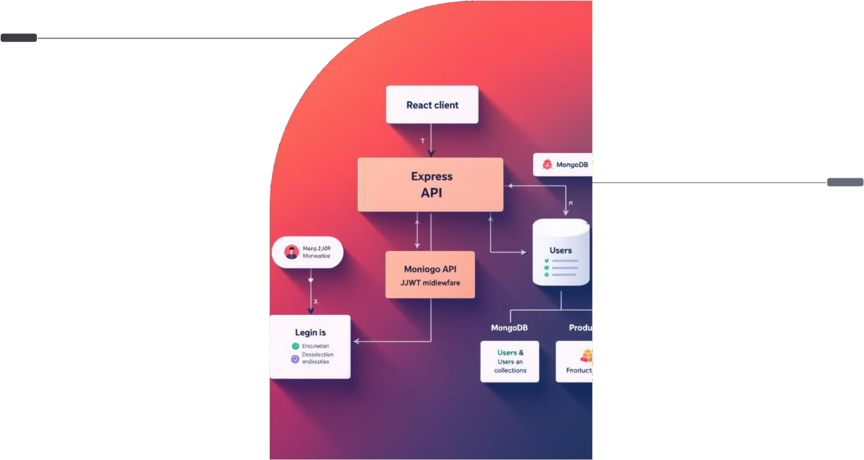
React Client
Sends API requests and receives JSON responses.
Express API
Validates JWT, routes requests to MongoDB collections.

Requirements Snapshot
  - Functional Requirements

User Authentication
Register and login functionality with JWT token generation and credential validation

Product CRUD Operations
Create, read, update, and delete products scoped to authenticated user's userId

Product Search
Case-insensitive name-based search using regex with optional pagination support

Data Validation
Input validation ensuring price ≥ 0, quantity ≥
0, and required fields present

  - Non-Functional Requirements

 Security
JWT with strong secret key, bcrypt password hashing, protected routes with authorization middleware

Performance
Paginated list endpoints, database indexes on {userId, createdAt} and {userId, name} fields

 Reliability
Fail-fast database connection, standardized error responses with consistent shape

Scalability
Stateless API design, modular layered architecture, horizontal scaling capability

Implementation Highlights

Auth Controller
Register with duplicate email check and password hashing, login with credential verification and token generation

Product Controller
Full CRUD implementation with userId scoping, case-insensitive search, createdAt sorting

Auth Middleware
Bearer token verification, req.user.id attachment, graceful error handling for missing/invalid tokens

Server Configuration
- CORS configured for development origin
- Environment-based PORT assignment
- MongoDB connection via MONGODB_URI
- Express.js route mounting at /api/v1

Key Features
- RESTful API design principles
- JWT token with 7-day expiration
- Case-insensitive product search
- Automatic createdAt sorting

Risks & Mitigations

1
2

Missing Environment Variables
Risk: JWT_SECRET or MONGODB_URI not set in
.env file causes startup failure
Mitigation: Implement startup checks with clear error messages and configuration guidance

Malformed Authorization Header
Risk: Missing or incorrectly formatted Bearer token leads to authentication failures
Mitigation: Return HTTP 401 with explicit error message and proper header format documentation

3
4

Duplicate Email Registration
Risk: Attempt to register existing email address violates unique constraint
Mitigation: Unique database index combined with conflict error handling and user-friendly message

Unbounded Result Lists
Risk: Large product collections cause slow queries and memory issues without pagination

Mitigation: Enforce pagination defaults with limit and offset parameters, recommend client- side controls

Value Proposition & Outcomes



Business Value
Dependable, secure inventory backend that's easy to integrate with existing systems and extend with additional features as business needs evolve

Technical Value
Clean architectural patterns including separation of concerns, stable JWT-based authentication, and predictable RESTful API design

Outcome
Audit-friendly, user-private inventory operations suitable for small businesses and solo sellers managing product catalogs securely

Appendix: Quick Start Guide
  - Prerequisites
    - Node.js version 20.x or higher
    - Running MongoDB instance or connection string
    - npm package manager

  - Environment Setup

MONGODB_URI=your_mongodb_connection_string JWT_SECRET=your_jwt_secret_key
PORT=5000

  - Installation & Running

npm install
npm run dev

  - Testing
Use the provided Postman collection to test authentication endpoints (register/login) and product CRUD operations with JWT-protected routes.

